- Create an S3 bucket and upload some objects to S3.
Step 1: Login to AWS and select S3create bucketprovide detailscreate bucket.
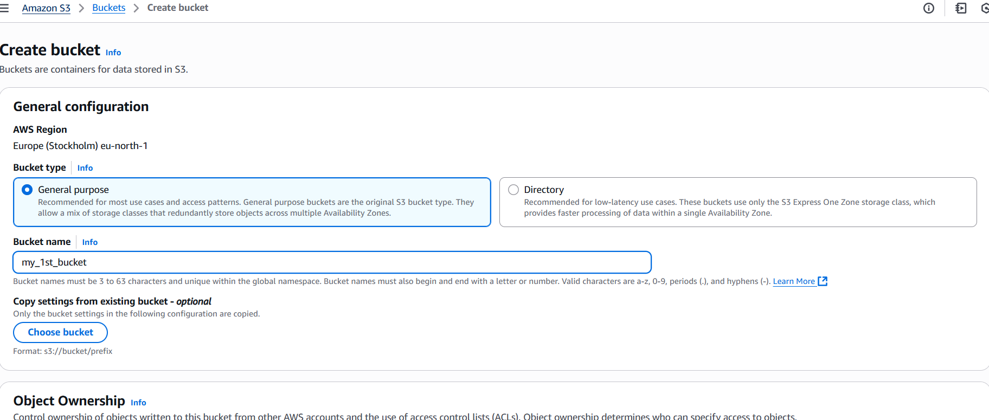
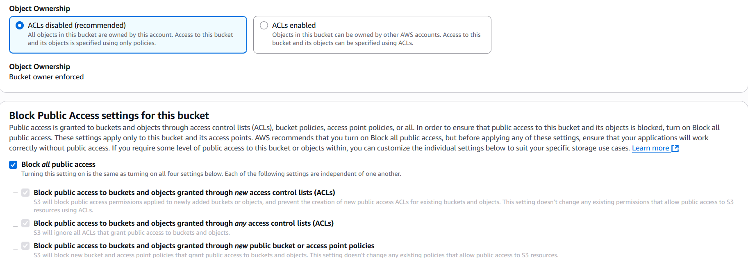
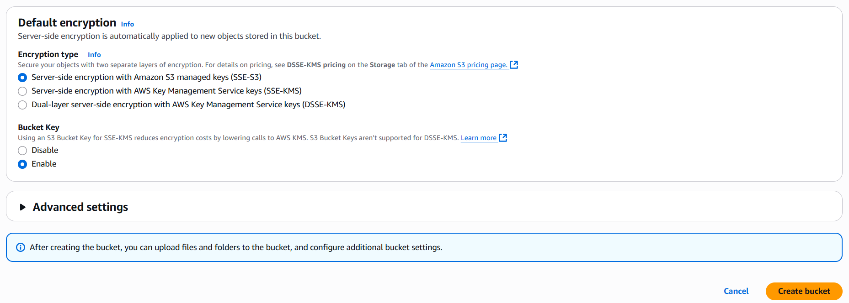

Step 2: Select your bucketuploadAdd filesupload.
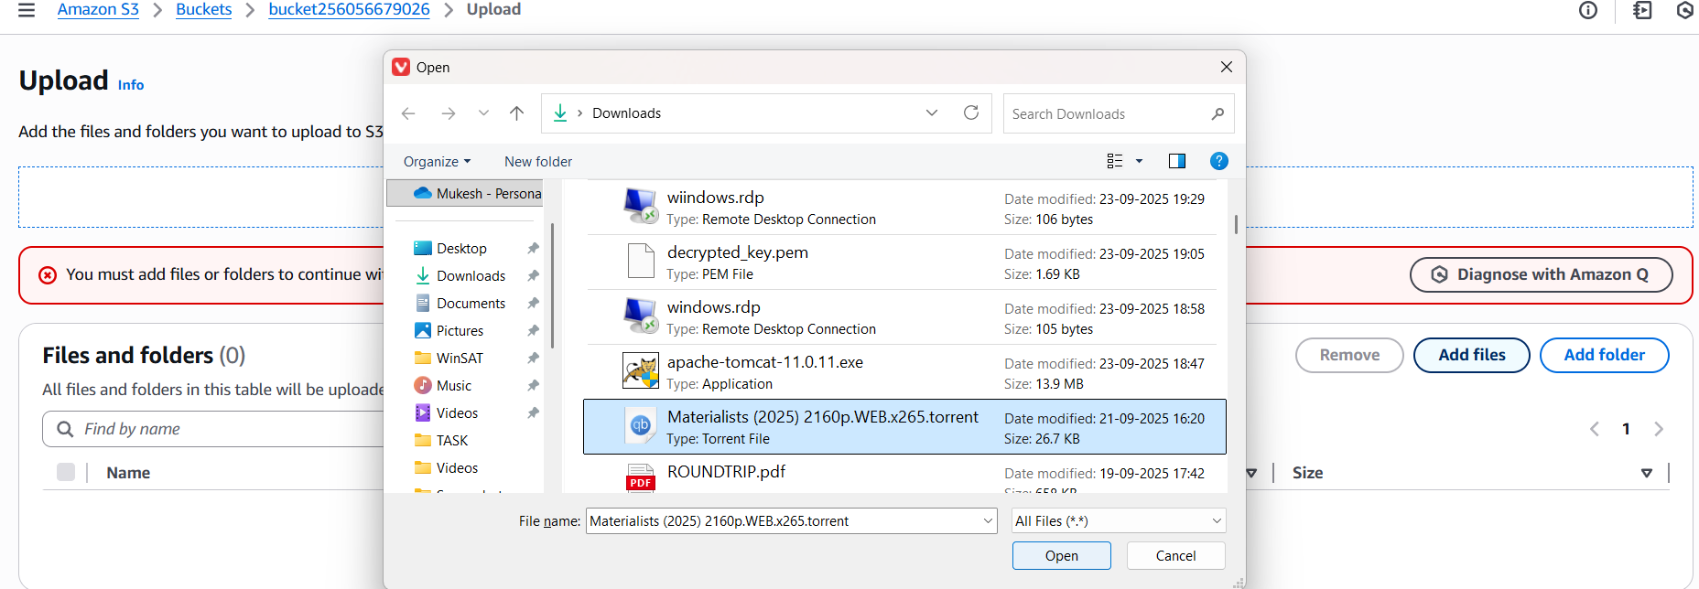
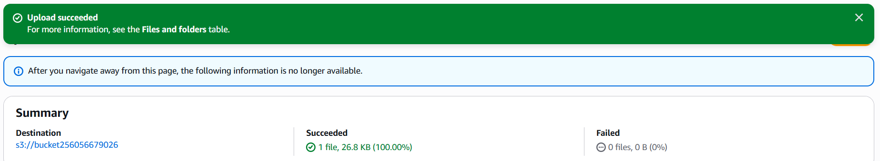
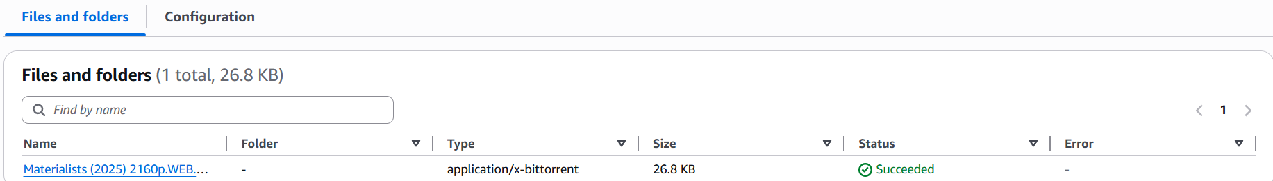

- Deploy a static website in the S3 bucket.
Step 1: Select bucketpropertiesEdit Static website hosting.
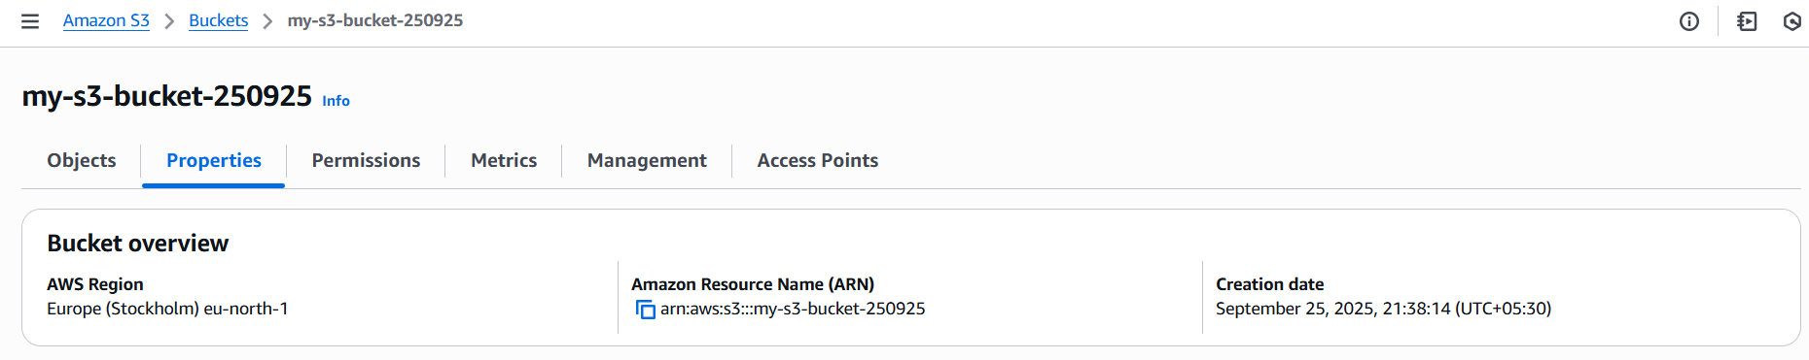
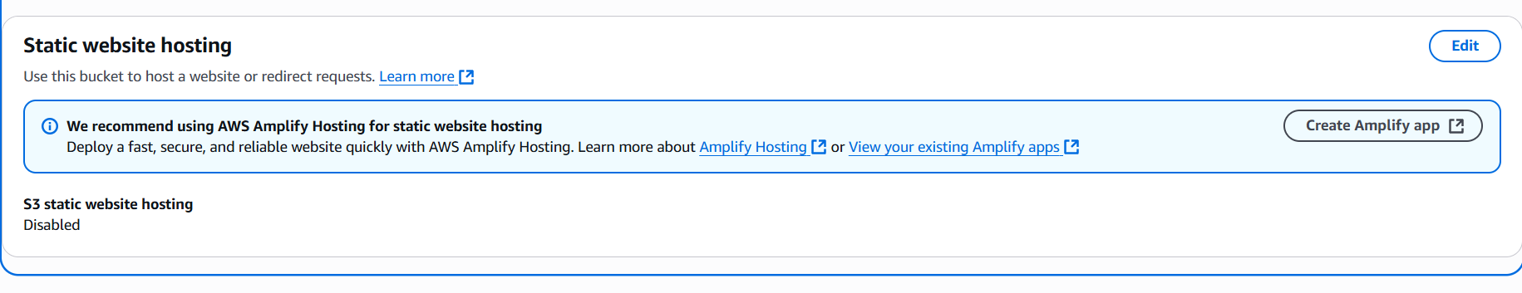

Step 2: select Enabletype index.html error.htmlSave changes.
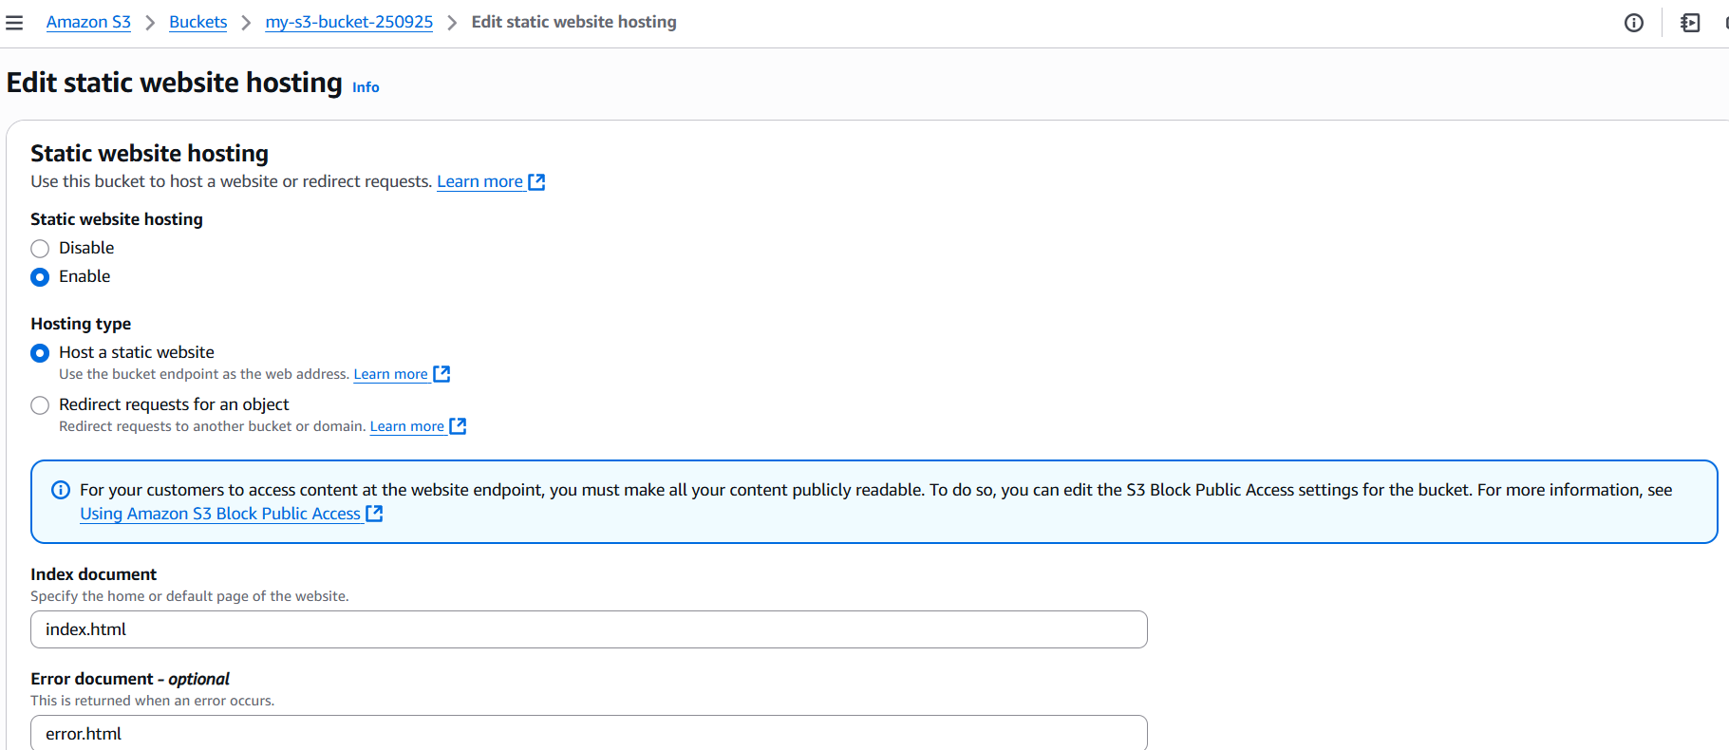
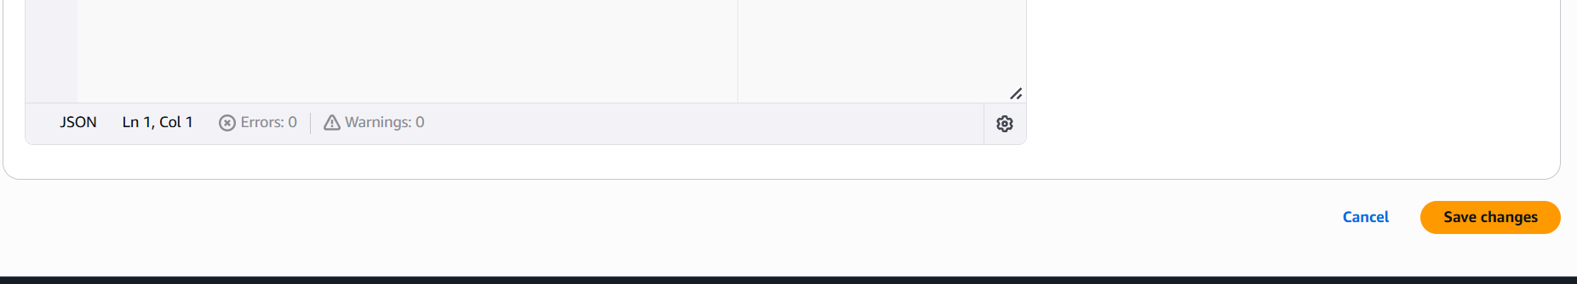
Step 3: Run object URL in browser.
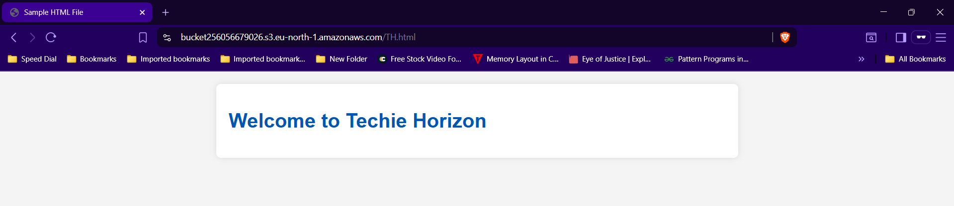

- Enable cross-region replication on S3 buckets.
Step 1: Create 2 buckets of different regions.
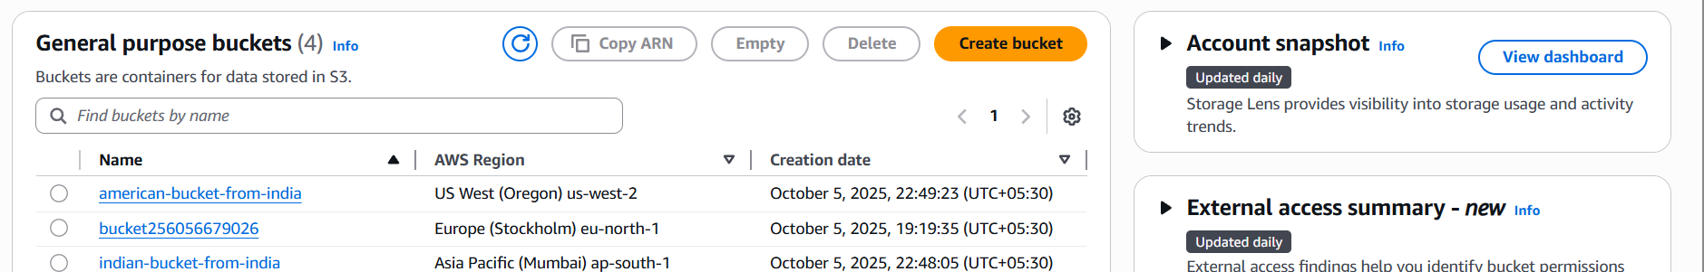

Step 2: Select a Bucketmanagementcreate replicate ruleEnter detailssavesubmit.
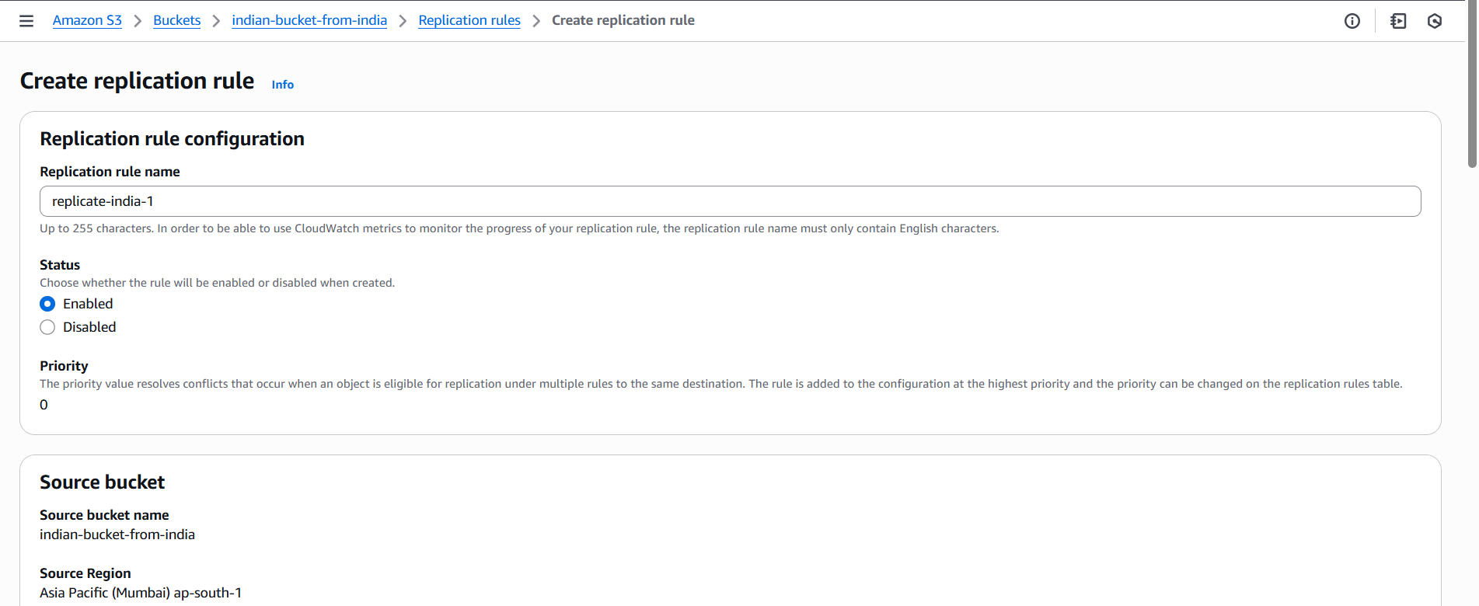
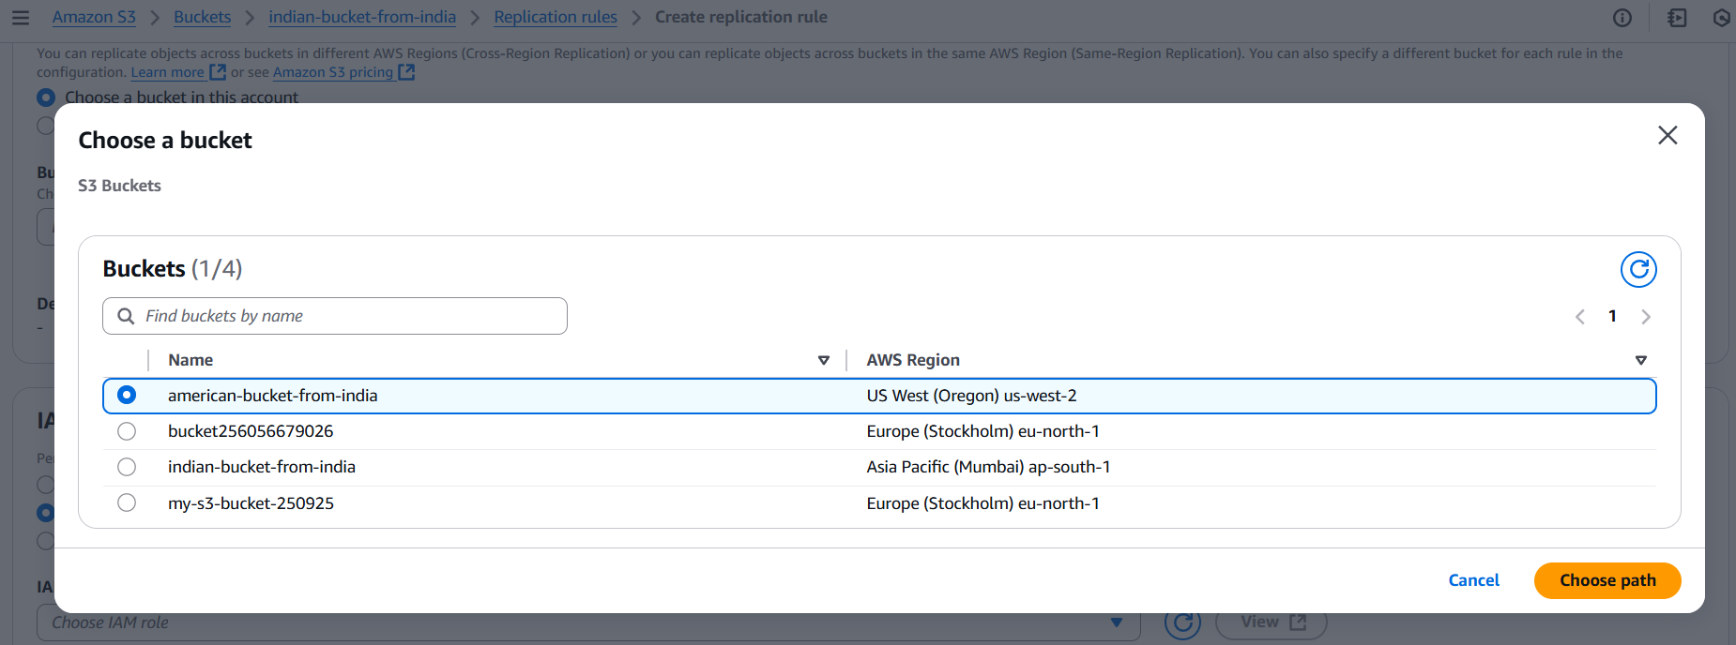
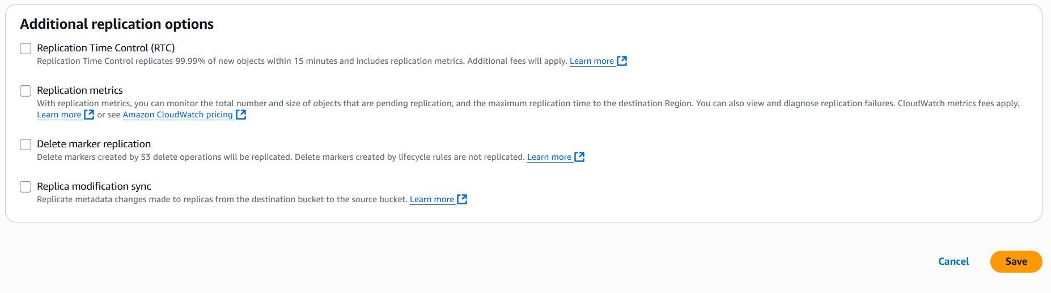
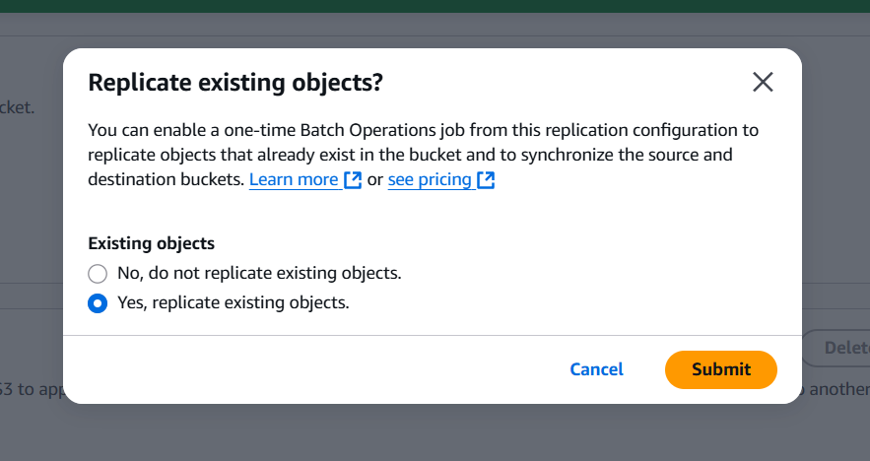
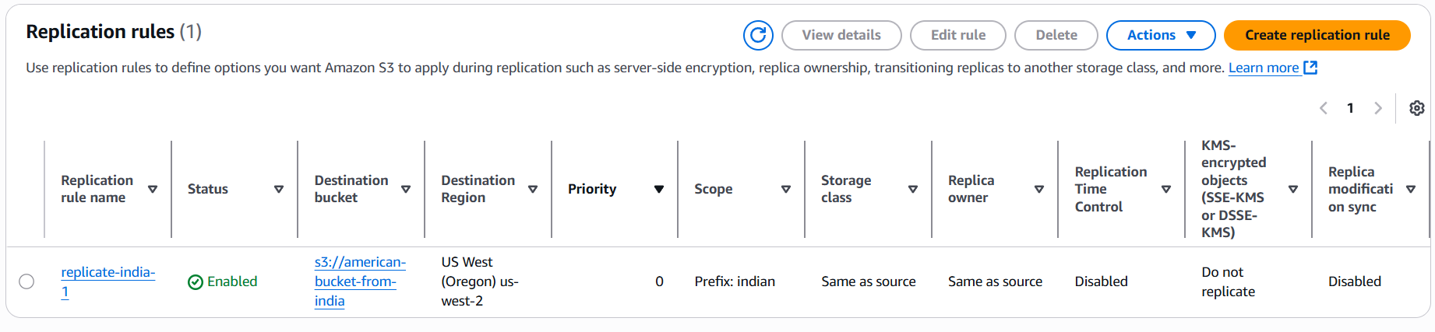

- Configure a bucket policy so only the Admin user can see the objects of the S3 bucket.
Step 1: Select a BucketPropertiescopy ARN id.
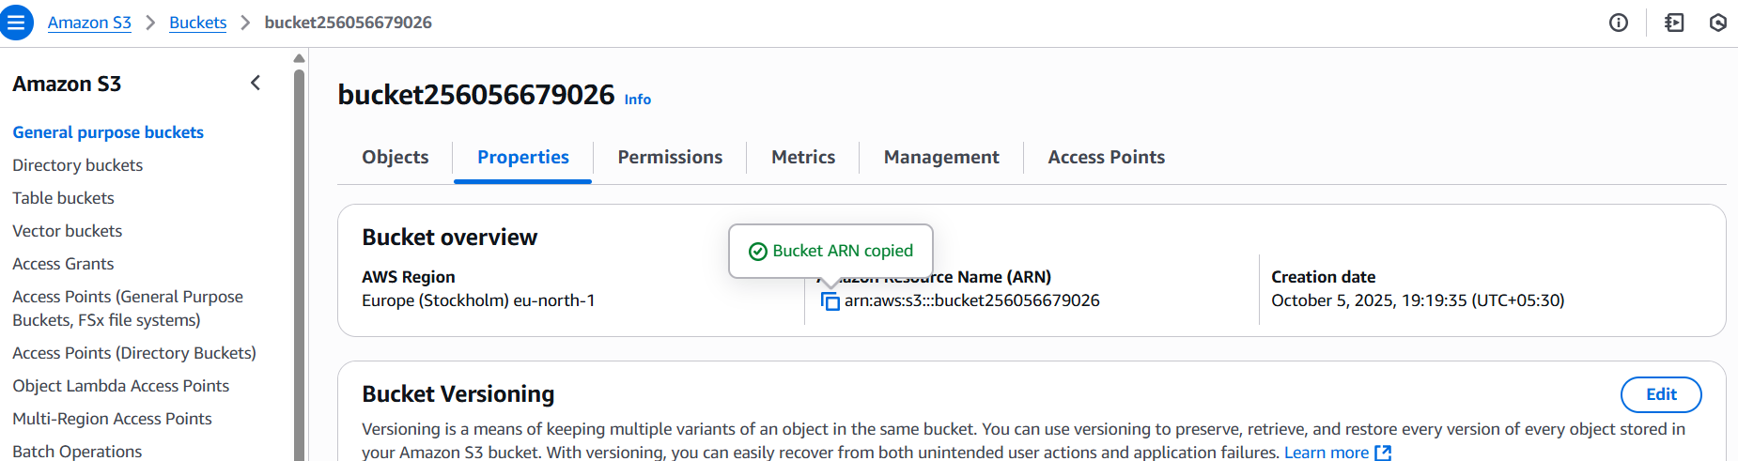
Step 2: In browser search AWS policy generator and provide detailsselect generate policy copy policy.
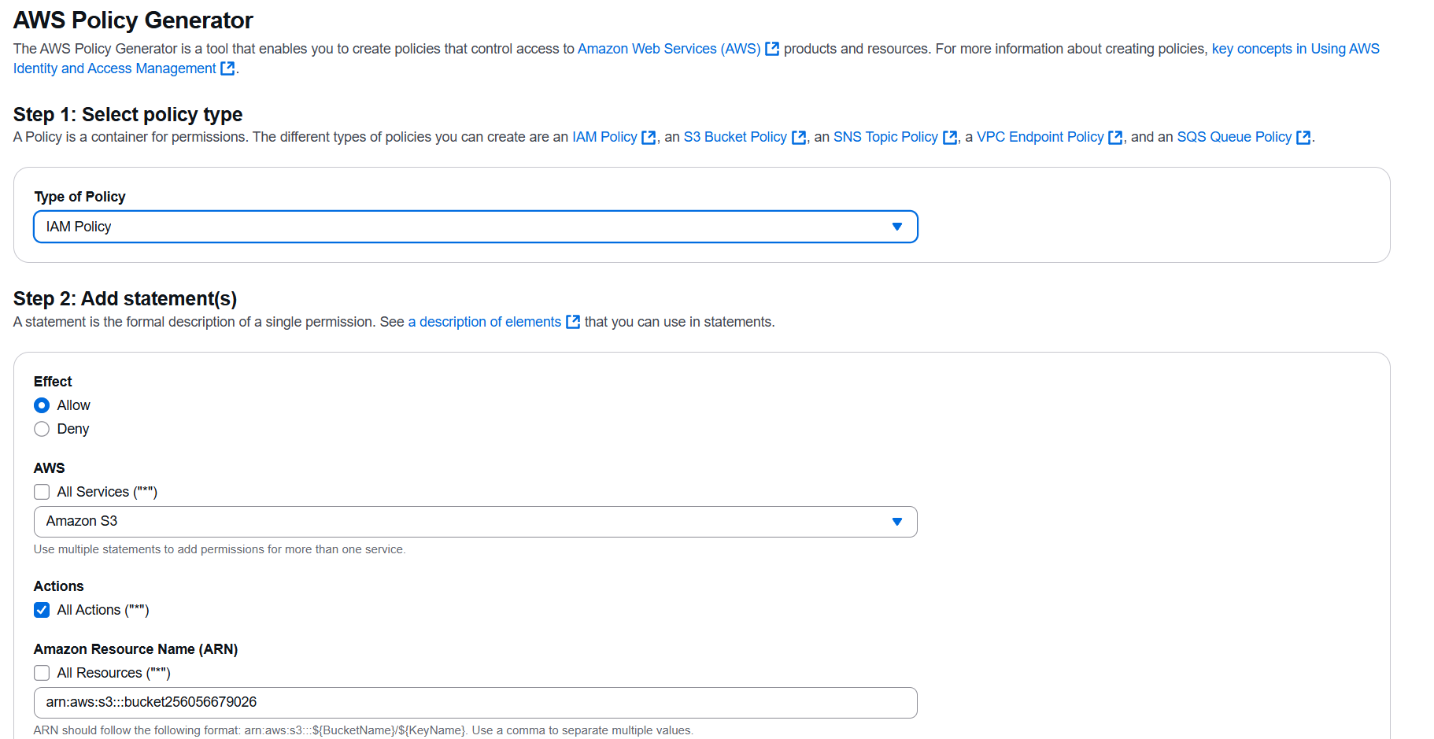
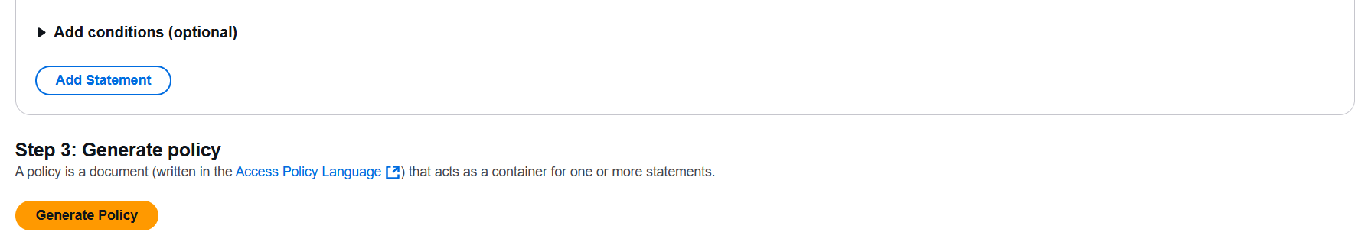

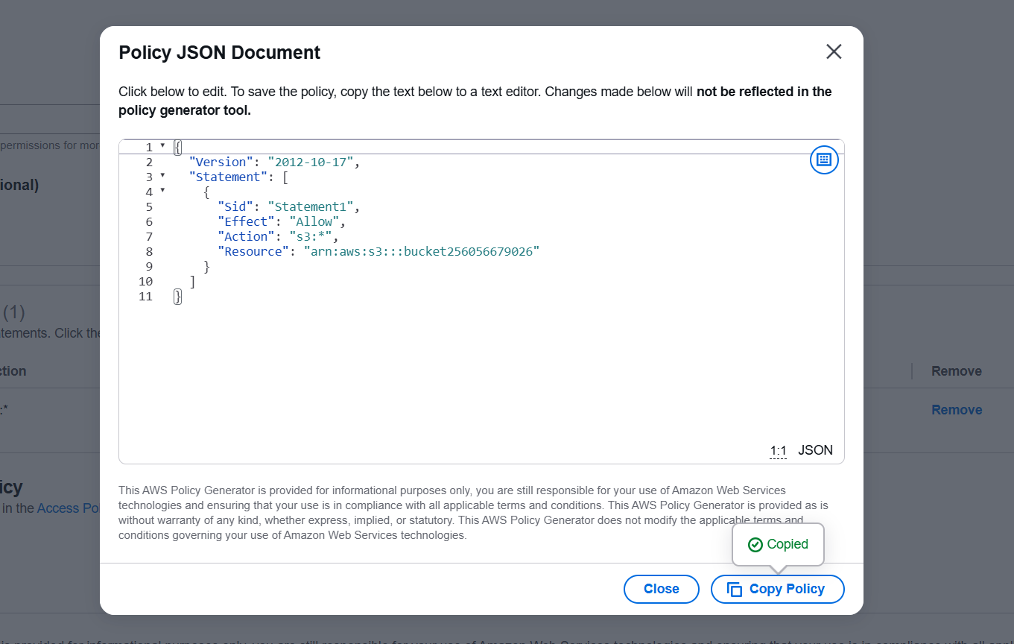
Step 3: Goto IAMpoliciescreate policyjsonreplace the policyNextcreate policy.
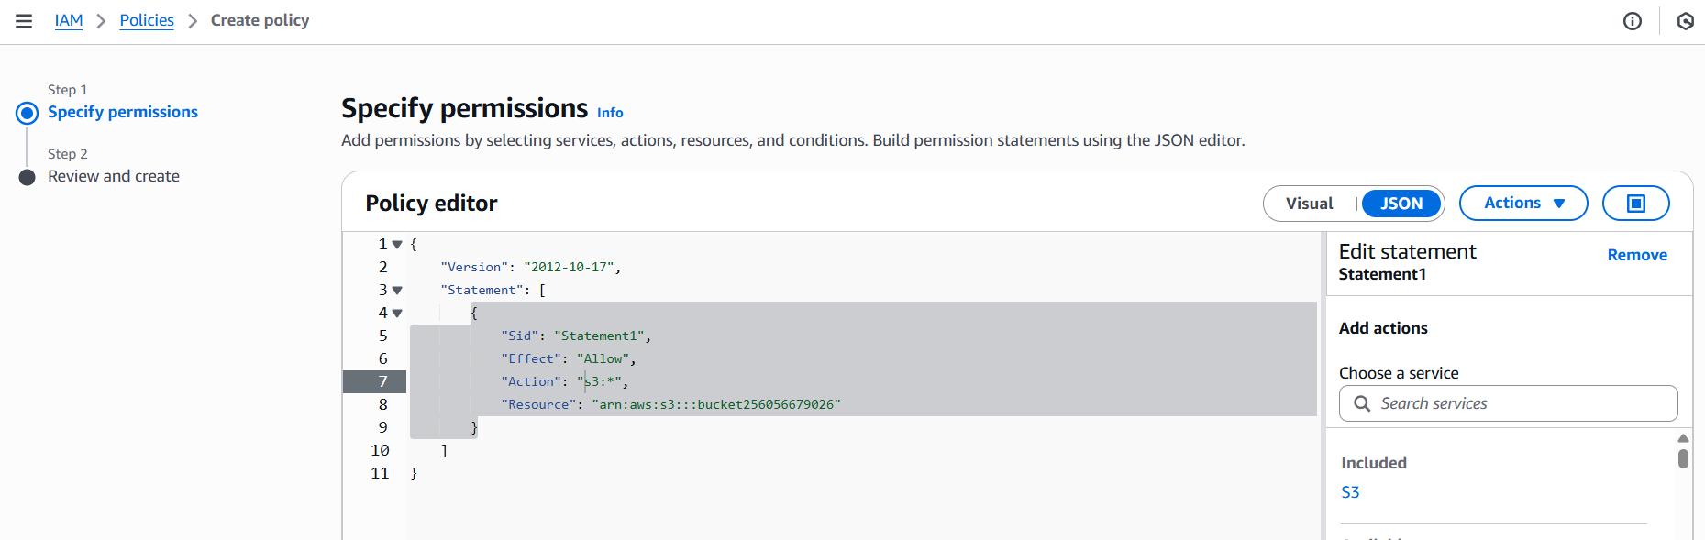
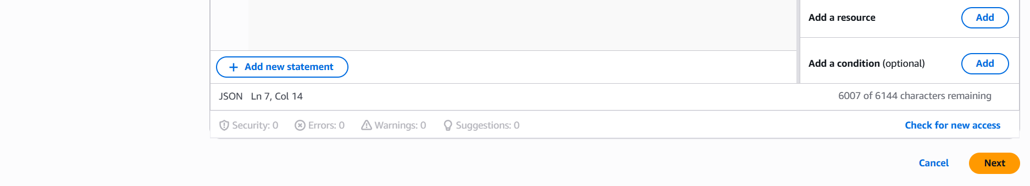
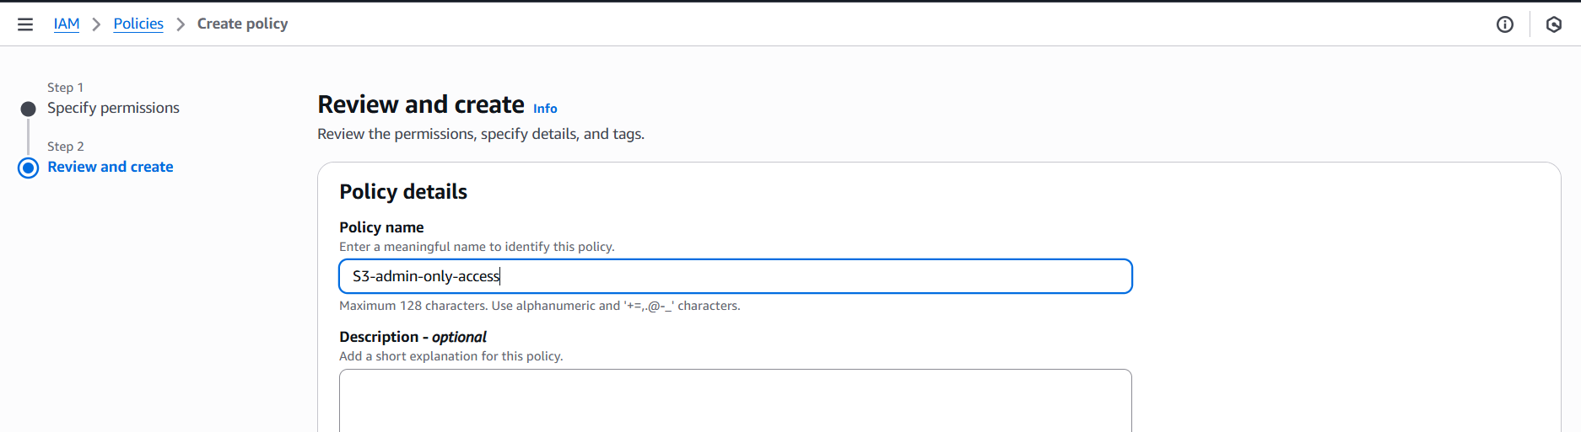

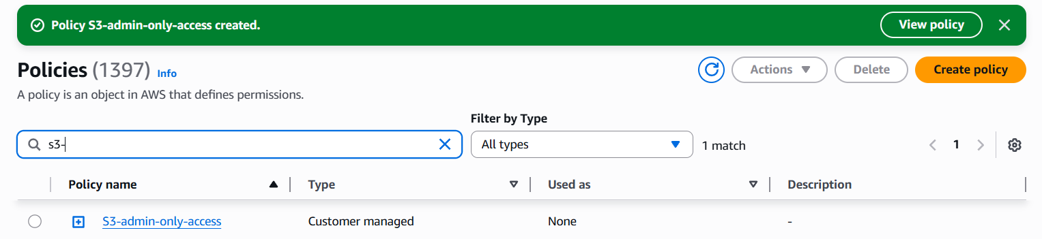
Step 4: Goto IAMusercreate userAttach policies directlyCreate user.
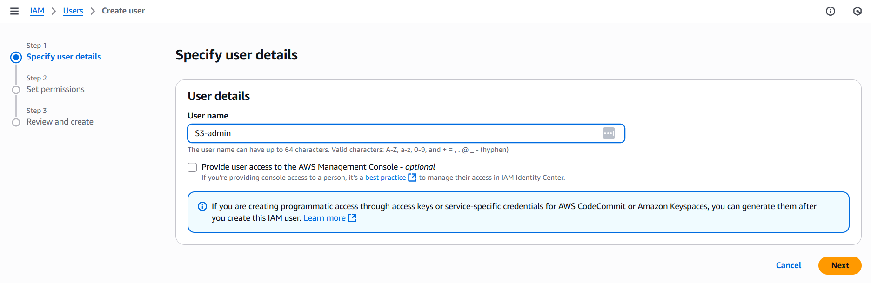
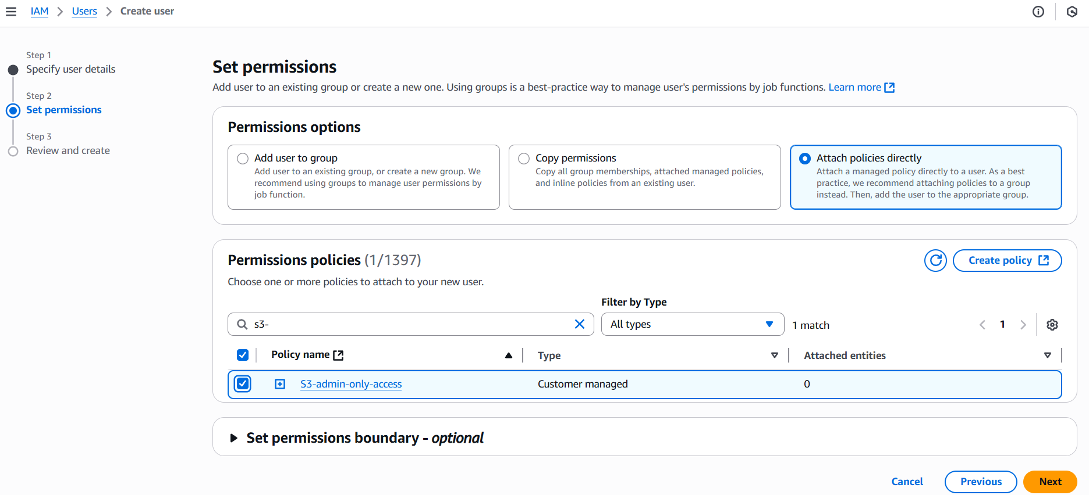
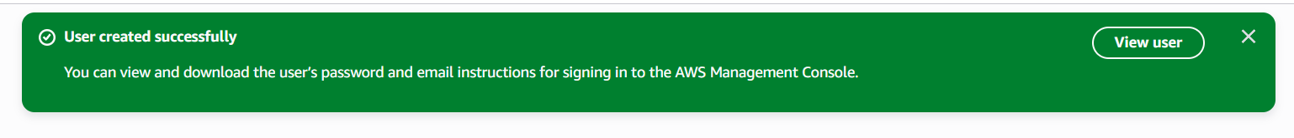

- Set up lifecycle policies to automatically transition or delete objects based on specific criteria.
Step 1:

